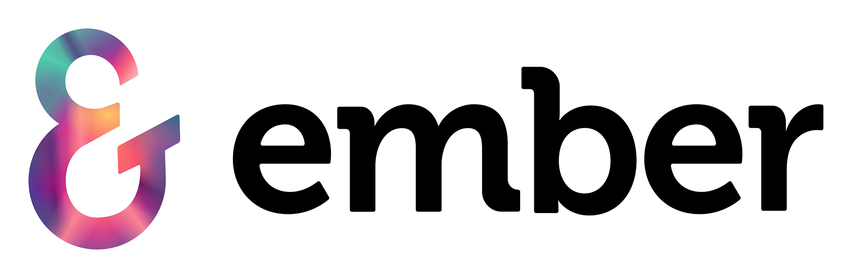

[Non-Disclosure Agreement Template]
(Your Company Name)
Non-Disclosure Agreement

This non-disclosure agreement (hereafter referred to as “The Agreement”) is entered between the following parties.

1. The parties
This agreement is between:
(Your company name) a company registered at (your company address) (the disclosing party)
(Receiving party) a company registered at (the company address) (the receiving party)
OR
(Individual’s name and details)
Together these will be referred to as “The parties”.

2. Definitions
[We have created a few definitions for you to use, but feel free to add your own depending on terms and phrases you’ve used in the agreement.]
In this agreement, you will come across certain terms. The meaning of these terms and phrases are defined below:
a) “Disclosing party”
This refers to the party (your company name) who is sharing or disclosing information under the terms in this agreement.
b) “Receiving party”
This refers to the party (recipient party name(s)) who is receiving confidential information under the terms of this agreement.
c) “Confidential information”
This refers to information shared by the disclosing party (your company name) under the terms of this agreement. This includes, but is not limited to, data, customer lists, trade secrets, financial information, commercially sensitive information, forecasts or product development information.

3. Confidential information
The disclosing party (your company name) will provide certain confidential information to the receiving party (company or individual’s name).
All information disclosed by the disclosing party, (your company name) whether in (but not limited to) writing, emails or conversations should be considered confidential.
OR
[Add what specific confidential information you will be sharing here.]

Exclusions
In this agreement, confidential information does not refer to the following:
a) Information which is already available in the public domain.
b) Information which has been disclosed by (your company name) before the signing of the agreement
c) Information which has been independently discovered by the receiving party

Obligations to keep information confidential
In order to keep information disclosed by (your company name) confidential, we require the following:
[Add any requirements you need to ensure that information is kept confidential, such as the implementation of security systems etc.]

Duration
The agreement will commence from the date of signature and will remain in effect until (date) OR until the disclosing party (your company name) gives written notice releasing the receiving party (company name) from the agreement.

Return of information
The receiving party (company name) shall immediately on request return, delete or destroy all confidential information shared by the disclosing party (your company name).

Additional information
[Add any additional information or clauses.]

Signatures
Please sign below to confirm your agreement to the terms of this non-disclosure agreement.

Disclosing party
Signed on behalf of (your company name) …...............................
Date:….............................

Receiving party
Signed on behalf of (your company name) …...............................
Date:….............................

